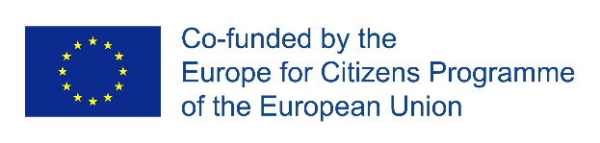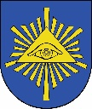

The Wilamowice Commune will soon start implementing the project under the Europe for Citizens Program

Once again, the municipality of Wilamowice has received funding for the implementation of the international project "Solidarity in partnership: social and intercultural cooperation - the key to European solidarity". The task was co-financed by the European Commission under the program "Europe for Citizens" and will be implemented from 27.05.2022 to 30.05.2022.

Short description of the project:
The main objective of our project is to support the activities of local government bodies and non-governmental organizations in developing and implementing a more rational partnership policy based on the principle of solidarity, which should unite all EU countries.
During conceptual workshops, together we will develop the campaign "Solidarity in Partnership - social and intercultural cooperation - the key to European solidarity", which will emphasize the need for cooperation within the EU if we want to achieve common goals (social, economic, political).
We will also develop a comprehensive agreement "Cultural Cooperation in the EU - Let's get to know our heritage" as a signpost for the development of cultural cooperation.
The participants of the project will integrate with the local community during their joint participation in the Wilamowskie Śmiergusty, the main artistic and cultural event of our region. There will be a number of performances by bands, brass bands and music groups from partner communes as well as competitions and quizzes.
Debates with Eurosceptics will aim at understanding their arguments and presenting rational counter-arguments. We will deal with antimigrant rhetoric. Together we will consider whether the exit from the EU is the only way to solve the problems of EU countries.
During the debate we will confront the arguments concerning the future of the EU. Do we opt for disintegration, stabilisation or further integration of the EU? This will be important for us in view of the cooperation agreements we intend to conclude.
We will make a film "Seniors and young people - together we build the future of the EU" presenting talks between seniors and young people about the future of the EU.
Agreements in various thematic areas concluded during the project will show that thanks to solidarity action it is possible to successfully cooperate in shaping the future of the EU without antagonisms and cultural intolerance.

Project partners:
1. Kisújszállás Város Önkormányzata - Hungary
2. Obec Horná Súča - Slovakia
3. Mesto Rajecké Teplice - Slovakia
4. Městský úřad Dolní Benešov - Czech Republic
5. Grad Županja - Croatia
6. Grad Klanjec - Croatia
7. Obec Kunerad - Slovakia

